UNITED STATES
SECURITIES AND EXCHANGE COMMISSION
Washington, D.C. 20549
FORM 6-K

REPORT OF FOREIGN PRIVATE ISSUER PURSUANT TO RULE 13a-16 OR 15d-16
OF THE SECURITIES EXCHANGE ACT OF 1934
FOR THE MONTH OF MAY 2026
COMMISSION FILE NUMBER 001-38976
Genmab A/S
(Exact name of Registrant as specified in its charter)
Carl Jacobsens Vej 30
2500 Valby
Denmark
+45 70 20 27 28
(Address of principal executive offices)
Indicate by check mark whether the registrant files or will file annual reports under cover Form 20-F or Form 40-F.
Form 20-F Form 40-F
This report on Form 6-K shall be deemed to be incorporated by reference in Genmab A/S’s registration statements on Form S-8 (File No. 333-232693, 333-253519, 333-262970, 333-277273, 333-284876 and 333-293505) and to be a part thereof from the date on which this report is filed, to the extent not superseded by documents or reports subsequently filed or furnished.

EXHIBIT INDEX
Exhibit |  |  | Description of Exhibit
99.1 |  |  | Company Announcement Dated May 8, 2026: Major Shareholder Announcement
99.2 |  |  | Orbis Shareholder Notification

SIGNATURE
Pursuant to the requirements of the Securities Exchange Act of 1934, the registrant has duly caused this report to be signed on its behalf by the undersigned, thereunto duly authorized.
 |  |  | GENMAB A/S
 |  |  | BY: |  |  | /s/ Anthony Pagano
 |  |  |  |  |  | Name: Anthony Pagano
 |  |  |  |  |  | Title: Executive Vice President & Chief Financial Officer

DATE: MAY 8, 2026

Exhibit 99.1


Major Shareholder Announcement
Company Announcement

•Major shareholder announcement for Genmab A/S

COPENHAGEN, Denmark; May 8, 2026 – Genmab A/S (Nasdaq: GMAB) announces under reference to Section 30 of the Danish Capital Markets Act that Orbis Investment Management Limited has informed us that through shares, as of May 8, 2026, Orbis Investment Management Limited controlled the voting rights to 3,166,357 shares in Genmab A/S, which amounts to 5.08% of the share capital and voting rights in Genmab A/S.

The major shareholder announcement of Orbis Investment Management Limited is attached to this announcement.

About Genmab
Genmab is an international biotechnology company dedicated to improving the lives of people with cancer and other serious diseases through innovative antibody medicines. For over 25 years, its passionate, innovative and collaborative team has advanced a broad range of antibody-based therapeutic formats, including bispecific antibodies, antibody–drug conjugates (ADCs), immune-modulating antibodies and other next-generation modalities. Genmab’s science powers eight approved antibody medicines, and the company is advancing a strong late-stage clinical pipeline, including wholly owned programs, with the goal of delivering transformative medicines to patients.

Established in 1999, Genmab is headquartered in Copenhagen, Denmark, with international presence across North America, Europe and Asia Pacific. For more information, please visit Genmab.com and follow us on LinkedIn and X.
Contact:
Marisol Peron, Senior Vice President, Global Communications & Corporate Affairs
T: +1 609 524 0065; E: mmp@genmab.com

Andrew Carlsen, Vice President, Head of Investor Relations
T: +45 3377 9558; E: acn@genmab.com

This Company Announcement contains forward looking statements. The words “believe,” “expect,” “anticipate,” “intend” and “plan” and similar expressions identify forward looking statements. Actual results or performance may differ materially from any future results or performance expressed or implied by such statements. The important factors that could cause our actual results or performance to differ materially include, among others, risks associated with preclinical and clinical development of products, uncertainties related to the outcome and conduct of clinical trials including unforeseen safety issues, uncertainties related to product manufacturing, the lack of market acceptance of our products, our inability to manage growth, the competitive environment in relation to our business area and markets, our inability to attract and retain suitably qualified personnel, the unenforceability or lack of protection of our patents and proprietary rights, our relationships with affiliated entities, changes and developments in technology which may render our products or technologies obsolete, and other factors. For a further discussion of these risks, please refer to the risk management sections in Genmab’s most recent financial reports, which are available on www.genmab.com and the risk factors included in Genmab’s most recent Annual Report on Form 20-F and other filings with the U.S. Securities and Exchange Commission (SEC), which are available at www.sec.gov. Genmab does not undertake any obligation to update or revise forward looking statements in this Company Announcement nor to confirm such statements to reflect subsequent events or circumstances after the date made or in relation to actual results, unless required by law.

Genmab A/S and/or its subsidiaries own the following trademarks: Genmab®; the Y-shaped Genmab logo®; Genmab in combination with the Y-shaped Genmab logo®; HuMax®; DuoBody®; HexaBody®; DuoHexaBody®, HexElect® and KYSO®.
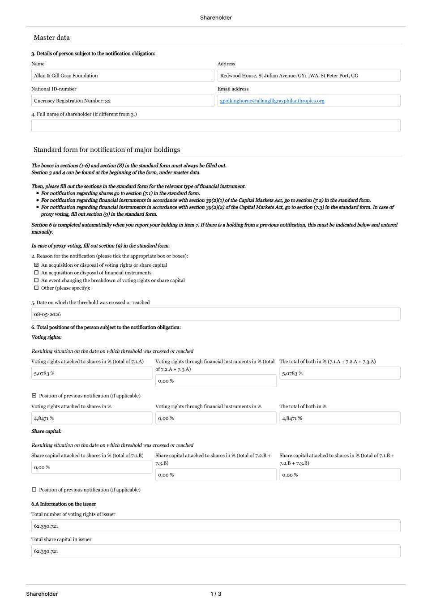
Genmab A/S  Carl Jacobsens Vej 30  2500 Valby, Denmark |  |  | Tel: +45 7020 2728  www.genmab.com |  |  | Company Announcement no. 26  Page 1/1  CVR no. 2102 3884  LEI Code 529900MTJPDPE4MHJ122

Shareholder Shareholder 1 / 3 Master data Standard form for notification of major holdings 3. Details of person subject to the notification obligation: Name Allan & Gill Gray Foundation Address Redwood House, St Julian Avenue, GY1 1WA, St Peter Port, GG National ID-number Guernsey Registration Number: 32 Email address gpolkinghorne@allangillgrayphilanthropies.org 4. Full name of shareholder (if different from 3.) The boxes in sections (1-6) and section (8) in the standard form must always be filled out. Section 3 and 4 can be found at the beginning of the form, under master data. Then, please fill out the sections in the standard form for the relevant type of financial instrument. For notification regarding shares go to section (7.1) in the standard form. For notification regarding financial instruments in accordance with section 39(2)(1) of the Capital Markets Act, go to section (7.2) in the standard form. For notification regarding financial instruments in accordance with section 39(2)(2) of the Capital Markets Act, go to section (7.3) in the standard form. In case of proxy voting, fill out section (9) in the standard form. Section 6 is completed automatically when you report your holding in item 7. If there is a holding from a previous notification, this must be indicated below and entered manually. In case of proxy voting, fill out section (9) in the standard form. Other (please specify): An event changing the breakdown of voting rights or share capital An acquisition or disposal of financial instruments An acquisition or disposal of voting rights or share capital 2. Reason for the notification (please tick the appropriate box or boxes): 5. Date on which the threshold was crossed or reached 08-05-2026 6. Total positions of the person subject to the notification obligation: Voting rights: Resulting situation on the date on which threshold was crossed or reached Voting rights attached to shares in % (total of 7.1.A) 5,0783 % Voting rights through financial instruments in % (total of 7.2.A + 7.3.A) 0,00 % The total of both in % (7.1.A + 7.2.A + 7.3.A) 5,0783 % Position of previous notification (if applicable) Voting rights attached to shares in % 4,8471 % Voting rights through financial instruments in % 0,00 % The total of both in % 4,8471 % Share capital: Resulting situation on the date on which threshold was crossed or reached Share capital attached to shares in % (total of 7.1.B) 0,00 % Share capital attached to shares in % (total of 7.2.B + 7.3.B) 0,00 % Share capital attached to shares in % (total of 7.1.B + 7.2.B + 7.3.B) 0,00 % Position of previous notification (if applicable) 6.A Information on the issuer Total number of voting rights of issuer 62.350.721 Total share capital in issuer 62.350.721

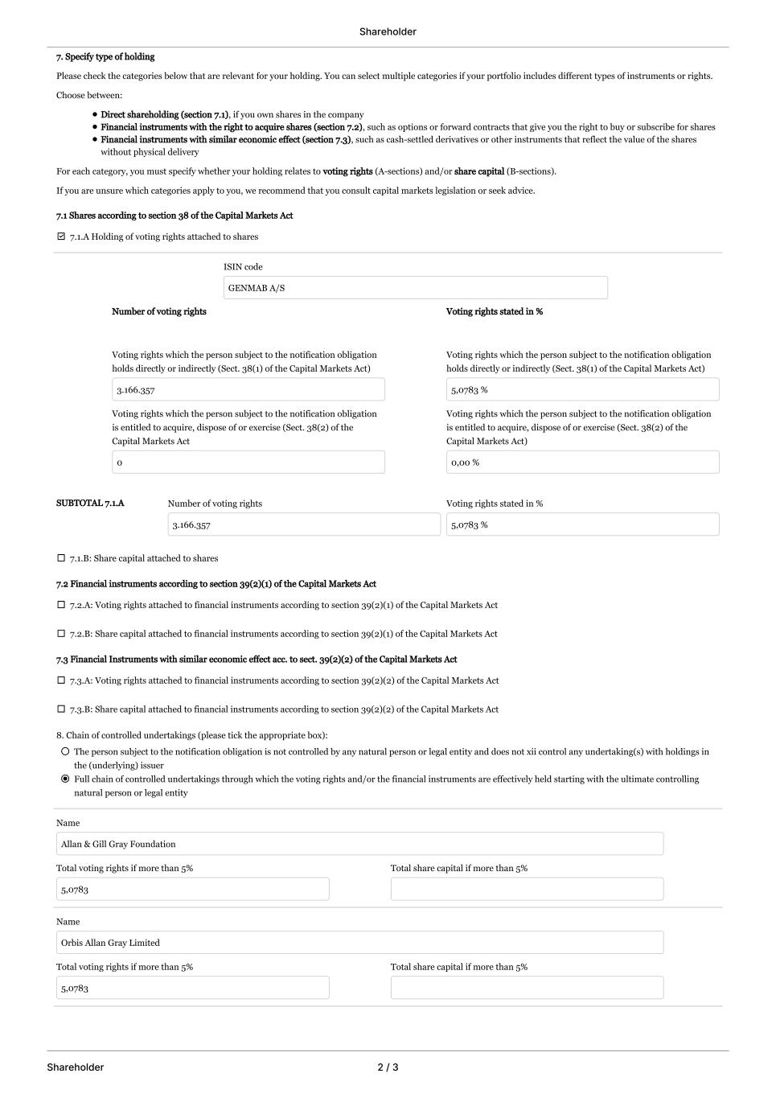
Shareholder Shareholder 2 / 3 7. Specify type of holding Please check the categories below that are relevant for your holding. You can select multiple categories if your portfolio includes different types of instruments or rights. Choose between: Direct shareholding (section 7.1), if you own shares in the company Financial instruments with the right to acquire shares (section 7.2), such as options or forward contracts that give you the right to buy or subscribe for shares Financial instruments with similar economic effect (section 7.3), such as cash-settled derivatives or other instruments that reflect the value of the shares without physical delivery For each category, you must specify whether your holding relates to (A-sections) and/or (B-sections).voting rights share capital If you are unsure which categories apply to you, we recommend that you consult capital markets legislation or seek advice. 7.1 Shares according to section 38 of the Capital Markets Act 7.1.A Holding of voting rights attached to shares ISIN code GENMAB A/S Number of voting rights Voting rights stated in % Voting rights which the person subject to the notification obligation holds directly or indirectly (Sect. 38(1) of the Capital Markets Act) 3.166.357 Voting rights which the person subject to the notification obligation holds directly or indirectly (Sect. 38(1) of the Capital Markets Act) 5,0783 % Voting rights which the person subject to the notification obligation is entitled to acquire, dispose of or exercise (Sect. 38(2) of the Capital Markets Act 0 Voting rights which the person subject to the notification obligation is entitled to acquire, dispose of or exercise (Sect. 38(2) of the Capital Markets Act) 0,00 % SUBTOTAL 7.1.A Number of voting rights 3.166.357 Voting rights stated in % 5,0783 % 7.1.B: Share capital attached to shares 7.2 Financial instruments according to section 39(2)(1) of the Capital Markets Act 7.2.A: Voting rights attached to financial instruments according to section 39(2)(1) of the Capital Markets Act 7.2.B: Share capital attached to financial instruments according to section 39(2)(1) of the Capital Markets Act 7.3 Financial Instruments with similar economic effect acc. to sect. 39(2)(2) of the Capital Markets Act 7.3.A: Voting rights attached to financial instruments according to section 39(2)(2) of the Capital Markets Act 7.3.B: Share capital attached to financial instruments according to section 39(2)(2) of the Capital Markets Act Full chain of controlled undertakings through which the voting rights and/or the financial instruments are effectively held starting with the ultimate controlling natural person or legal entity The person subject to the notification obligation is not controlled by any natural person or legal entity and does not xii control any undertaking(s) with holdings in the (underlying) issuer 8. Chain of controlled undertakings (please tick the appropriate box): Name Allan & Gill Gray Foundation Total voting rights if more than 5% 5,0783 Total share capital if more than 5% Name Orbis Allan Gray Limited Total voting rights if more than 5% 5,0783 Total share capital if more than 5%

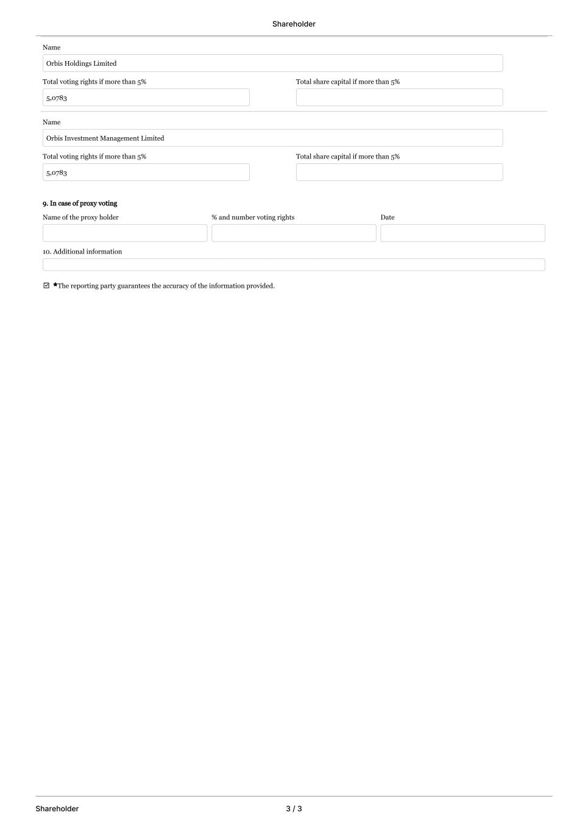
Shareholder Shareholder 3 / 3 Name Orbis Holdings Limited Total voting rights if more than 5% 5,0783 Total share capital if more than 5% Name Orbis Investment Management Limited Total voting rights if more than 5% 5,0783 Total share capital if more than 5% 9. In case of proxy voting Name of the proxy holder % and number voting rights Date 10. Additional information ⭐The reporting party guarantees the accuracy of the information provided.

