UNITED STATES
SECURITIES AND EXCHANGE COMMISSION
Washington, D.C. 20549
FORM 6-K

REPORT OF FOREIGN PRIVATE ISSUER PURSUANT TO RULE 13a-16 OR 15d-16
OF THE SECURITIES EXCHANGE ACT OF 1934
FOR THE MONTH OF SEPTEMBER 2026
COMMISSION FILE NUMBER 001-38976
Genmab A/S
(Exact name of Registrant as specified in its charter)
Carl Jacobsens Vej 30
2500 Valby
Denmark
+45 70 20 27 28
(Address of principal executive offices)
Indicate by check mark whether the registrant files or will file annual reports under cover Form 20-F or Form 40-F.
Form 20-F Form 40-F
This report on Form 6-K shall be deemed to be incorporated by reference in Genmab A/S’s registration statements on Form S-8 (File No. 333-232693, 333-253519, 333-262970, 333-277273, 333-284876 and 333-293505) and to be a part thereof from the date on which this report is filed, to the extent not superseded by documents or reports subsequently filed or furnished.

EXHIBIT INDEX
Exhibit |  |  | Description of Exhibit
99.1 |  |  | Company Announcement Dated September 8, 2026
99.2 |  |  | Extraordinary General Meeting Calling
99.3 |  |  | Appendix 1: Shareholder Letter

SIGNATURE
Pursuant to the requirements of the Securities Exchange Act of 1934, the registrant has duly caused this report to be signed on its behalf by the undersigned, thereunto duly authorized.
 |  |  | GENMAB A/S
 |  |  | BY: |  |  | /s/ Anthony Pagano
 |  |  |  |  |  | Name: Anthony Pagano
 |  |  |  |  |  | Title: Executive Vice President & Chief Financial Officer

DATE: September 8, 2026

Exhibit 99.1

Notice to Convene an Extraordinary General Meeting of Genmab A/S
Company Announcement

•Genmab A/S to hold an Extraordinary General Meeting on Wednesday, October 7, 2026

COPENHAGEN, Denmark; September 8, 2026 – Genmab A/S (Nasdaq: GMAB) convenes an Extraordinary General Meeting to be held on Wednesday, October 7, 2026, at 3:00 PM CEST at Genmab's offices, Carl Jacobsens Vej 30, 2500 Valby, Denmark.

The notice for the Extraordinary General Meeting, including Appendix 1: Shareholder Letter, is attached.

Shareholders are encouraged to visit Genmab’s website at Genmab.com for the Extraordinary General Meeting materials, including the notice and Shareholder Letter, as well as a video message and supporting materials relating to the Company’s shareholder outreach and Board remuneration proposal.

About Genmab
Genmab is an international biotechnology company dedicated to improving the lives of people with cancer and other serious diseases through innovative antibody medicines. For over 25 years, its passionate, innovative and collaborative team has advanced a broad range of antibody-based therapeutic formats, including bispecific antibodies, antibody–drug conjugates (ADCs), immune-modulating antibodies and other next-generation modalities. Genmab’s science powers eight approved antibody medicines, and the company is advancing a strong late-stage clinical pipeline, including wholly owned programs, with the goal of delivering transformative medicines to patients.

Established in 1999, Genmab is headquartered in Copenhagen, Denmark, with international presence across North America, Europe and Asia Pacific. For more information, please visit Genmab.com and follow us on LinkedIn and X.
Contact:
Marisol Peron, Senior Vice President, Global Communications & Corporate Affairs
T: +1 609 524 0065; E: mmp@genmab.com

Andrew Carlsen, Vice President, Head of Investor Relations
T: +45 3377 9558; E: acn@genmab.com
This Company Announcement contains forward looking statements. The words “believe,” “expect,” “anticipate,” “intend” and “plan” and similar expressions identify forward looking statements. Actual results or performance may differ materially from any future results or performance expressed or implied by such statements. The important factors that could cause our actual results or performance to differ materially include, among others, risks associated with pre-clinical and clinical development of products, uncertainties related to the outcome and conduct of clinical trials including unforeseen safety issues, uncertainties related to product manufacturing, the lack of market acceptance of our products, our inability to manage growth, the competitive environment in relation to our business area and markets, our inability to attract and retain suitably qualified personnel, the unenforceability or lack of protection of our patents and proprietary rights, our relationships with affiliated entities, changes and developments in technology which may render our products or technologies obsolete, and other factors. For a further discussion of these risks, please refer to the risk management sections in Genmab’s most recent financial reports, which are available on www.genmab.com and the risk factors included in Genmab’s most recent Annual Report on Form 20-F and other filings with the U.S. Securities and Exchange Commission (SEC), which are available at www.sec.gov. Genmab does not undertake any obligation to update or revise forward looking statements in this Company Announcement nor to confirm such statements to reflect subsequent events or circumstances after the date made or in relation to actual results, unless required by law.
Genmab A/S Tel: +45 7020 2728 Company Announcement no. 36
Carl Jacobsens Vej 30 www.genmab.com Page 1/2
2500 Valby, Denmark CVR no. 2102 3884
LEI Code 529900MTJPDPE4MHJ122

Notice to Convene an Extraordinary General Meeting of Genmab A/S
Genmab A/S and/or its subsidiaries own the following trademarks: Genmab®; the Y-shaped Genmab logo®; Genmab in combination with the Y-shaped Genmab logo®; HuMax®; DuoBody®; HexaBody®; DuoHexaBody®, HexElect® and KYSO®.

Exhibit 99.2
Genmab A/S Tel: +45 7020 2728 Company Announcement no. 36
Carl Jacobsens Vej 30 www.genmab.com Page 2/2
2500 Valby, Denmark CVR no. 2102 3884
LEI Code 529900MTJPDPE4MHJ122


To the Shareholders of Genmab A/S

September 8, 2026

EXTRAORDINARY GENERAL MEETING

Genmab A/S (in the following the “Company”) hereby invites its shareholders to attend an extraordinary general meeting on

Wednesday October 7, 2026, at 3:00 PM CEST

at the Company's offices, Carl Jacobsens Vej 30, DK-2500 Valby, Denmark.

Agenda:

1.Proposal from the Board of Directors on the approval of the remuneration to the Board of Directors for 2026.

2.Any other business.
Genmab A/S Carl Jacobsens Vej 30, DK-2500 Valby, Denmark
Tel. +45 7020 2728 www.genmab.com CVR no. 2102 3884

Complete Proposals

Re item 1 on the agenda:

At the Company's Annual General Meeting held on March 19, 2026, the proposal on the remuneration of the Board of Directors for 2026 was withdrawn. Following the Annual General Meeting, the Board of Directors conducted a comprehensive shareholder outreach, including engagement with a broad cross-section of the Company’s shareholders and proxy advisors, to better understand the concerns underlying the level of shareholder support.

A letter from the Chair of the Board of Directors and the Chair of the Compensation Committee is enclosed as Appendix 1. The letter summarizes the shareholder feedback received, the alternatives considered by the Board of Directors and the actions taken in response and explains the Board of Directors’ rationale for the remuneration proposal set out below. Shareholders are encouraged to read Appendix 1 in conjunction with this notice.

The Board of Directors proposes that the remuneration of the Board of Directors for 2026, including both (i) annual base fees and committee fees and (ii) share-based remuneration, shall remain unchanged from 2024 and 2025 and in accordance with the Remuneration Policy for the Board of Directors and the Executive Management of Genmab A/S (the "Remuneration Policy"), as further set out below.

Annual base fees and committee fees:
The annual base fees for members of the Board of Directors, including the committees thereof, shall be as follows:

-The annual base fee for members of the Board of Directors shall be DKK 600,000.
-The chair of the Board of Directors shall receive two times the annual base fee.
-The deputy chair of the Board of Directors shall receive one and a half times the annual base fee.
-The Audit and Finance Committee chair shall receive an annual fee of DKK 150,000 and the Audit and Finance Committee members an annual fee of DKK 100,000.
-The Compensation Committee chair shall receive an annual fee of DKK 120,000 and the Compensation Committee members an annual fee of DKK 80,000.
-The Nominating and Corporate Governance Committee chair shall receive an annual fee of DKK 100,000 and the Nominating and Corporate Governance Committee members an annual fee of DKK 70,000.
-The Scientific Committee chair shall receive an annual fee of DKK 130,000 and the Scientific Committee members an annual fee of DKK 100,000.
-All committee members shall receive a fee of DKK 10,000 per committee meeting.

Share-based remuneration:
In accordance with the Remuneration Policy, members of the Board of Directors shall receive share-based instruments in the form of restricted stock units (“RSUs”) subject to the terms set out in the Remuneration Policy, as follows:

-The chair of the Board of Directors receives RSUs corresponding to three (3) times the fixed annual base fee.
-The deputy chair and the members of the Board of Directors receive RSUs corresponding to two and a half (2.5) times the fixed annual base fee.

-o0o-

The proposal under item 1 is required to be adopted by a simple majority of votes.

The Company's share capital amounts to DKK 62,377,844 divided into shares of DKK 1 each or any multiple hereof. Each share amount of DKK 1 shall entitle the shareholder to one vote.

__________

In accordance with Section 99 of the Danish Companies Act, the following documents will be published on the Company’s website (www.genmab.com) no later than September 15, 2026: (1) the notice (including Appendix 1 thereto) of the Extraordinary General Meeting, (2) information on the total number of shares and votes issued by the Company on the date of the notice, (3) the agenda, (4) the complete proposals to be presented at the Extraordinary General Meeting, and (5) forms needed to register for the Extraordinary General Meeting and possible proxy voting and post voting.

Registration Date: A shareholder’s right to participate in and vote at the Extraordinary General Meeting is determined in proportion to the number of shares the shareholder owns on the registration date Wednesday September 30, 2026.

Registering attendance: Shareholders who wish to attend the Extraordinary General Meeting must register their attendance no later than Friday October 2, 2026, by:

•Visiting the Company’s website www.genmab.com or Euronext Securities’ website www.euronext.com/cph-agm no later than 11:59 PM CEST to register electronically; or
•Returning the enclosed registration form – duly completed and signed – to Euronext Securities, Nicolai Eigtveds Gade 8, DK-1402 Copenhagen K, Denmark by post no later than 11:59 PM CEST or by e-mail to CPH-investor@euronext.com; or
•Contacting Genmab A/S, Investor Relations, Carl Jacobsens Vej 30, DK-2500 Valby, Denmark either in person or in writing no later than 10:00 AM CEST; or
•Contacting Euronext Securities telephonically at +45 43 58 88 66 no later than 4:00 PM CEST.

As a prerequisite for attending, shareholders must provide an e-mail address when registering their attendance. Following registration, shareholders will receive an e-mail containing a QR code and instructions for accessing the General Meeting Portal. Shareholders attending in person must use the General Meeting Portal to verify their admission and to vote at the Extraordinary General Meeting.

Shareholders are encouraged to bring their own smartphone or tablet for this purpose. Wi-Fi and assistance will be available at the venue, and a limited number of pre-configured devices will be available for loan from Euronext Securities.

Please note that no food or refreshments will be served in connection with the Extraordinary General Meeting.

Voting: Voting will take place via the General Meeting Portal. Shareholders must log on to the portal in order to be able to vote. Shareholders who have granted proxies or voted by post prior to the General Meeting will not be able to vote at the General Meeting.

Proxy vote: Shareholders who do not expect to be able to participate in the General Meeting may:

•Assign a proxy to a person appointed by the shareholder. Proxies shall submit a request for an admission card as described above; or
•Assign a proxy to the Board of Directors. In this case your votes will be cast in accordance with the recommendations of the Board of Directors; or
•Assign a proxy to the Board of Directors by indicating how you wish your votes to be cast.

Go to the Company’s website www.genmab.com or Euronext Securities’ website www.euronext.com/cph-agm to assign a proxy to the Board of Directors to vote in accordance with its recommendations, or assign a proxy indicating how you wish your votes to be cast by checking the boxes on the electronic proxy form. This must be completed by 11:59 PM CEST on Friday October 2, 2026. You may alternatively complete and sign the enclosed proxy form and return it by post to Euronext Securities, Nicolai Eigtveds Gade 8, DK-1402 Copenhagen K, Denmark, or scan it and return it by e-mail to CPH-investor@euronext.com so that it is received by Euronext Securities by 11:59 PM CEST on Friday October 2, 2026.

Postal vote: Shareholders who do not expect to be able to participate in the General Meeting may also vote by post:

Go to the Company’s website www.genmab.com or www.euronext.com/cph-agm to vote by post. This must be completed by 10:00 AM CEST on Tuesday October 6, 2026. You may alternatively complete and sign the enclosed postal voting form and return it by post to Euronext Securities, Nicolai Eigtveds Gade 8, DK-1402 Copenhagen K, Denmark, or scan it and return it by e-mail to CPH-investor@euronext.com so that it is received by Euronext Securities by 10:00 AM CEST on Tuesday October 6, 2026.

Please note that you may either assign a proxy or vote by post, but not both.

Any shareholder, to whom an admission card already has been issued, but who is prevented from attending the Extraordinary General Meeting is kindly asked to notify the Company - preferably before Friday October 2, 2026.

Right to ask questions: Prior to the General Meeting, the shareholders may ask questions to the Company’s management in writing about the Company’s position or any of the other matters which are to be transacted at the General Meeting, or the Company’s relation to other companies in the Genmab Group. Shareholders’ questions must be sent by letter or email to either Marisol Peron (US), Senior Vice President, Global Communications & Corporate Affairs (mmp@genmab.com) or to Andrew Carlsen (EU), Vice President, Head of Investor Relations (acn@genmab.com). The question may be answered in writing by e.g. making the answer available on the Company’s website (www.genmab.com). The question may not be answered if the shareholder asking the question is not represented at the General Meeting. At the General Meeting, the shareholders may also ask questions to the Company’s management about the above matters.

Webcast: Shareholders who are not attending the Extraordinary General Meeting can watch the live webcast on the Company’s website www.genmab.com. The live webcast is publicly accessible and requires no registration.

Processing of personal data: The Company processes personal data about its shareholders in connection with the General Meeting. Please see Genmab A/S' Privacy Policy available on the Company's website: www.genmab.com/privacy/shareholders-genmab-a-s for details.

Copenhagen, September 8, 2026
On behalf of the Board of Directors
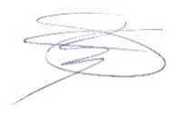
Deirdre P. Connelly
Chair


Scan the QR code with your smartphone or tablet to go to the registration site.

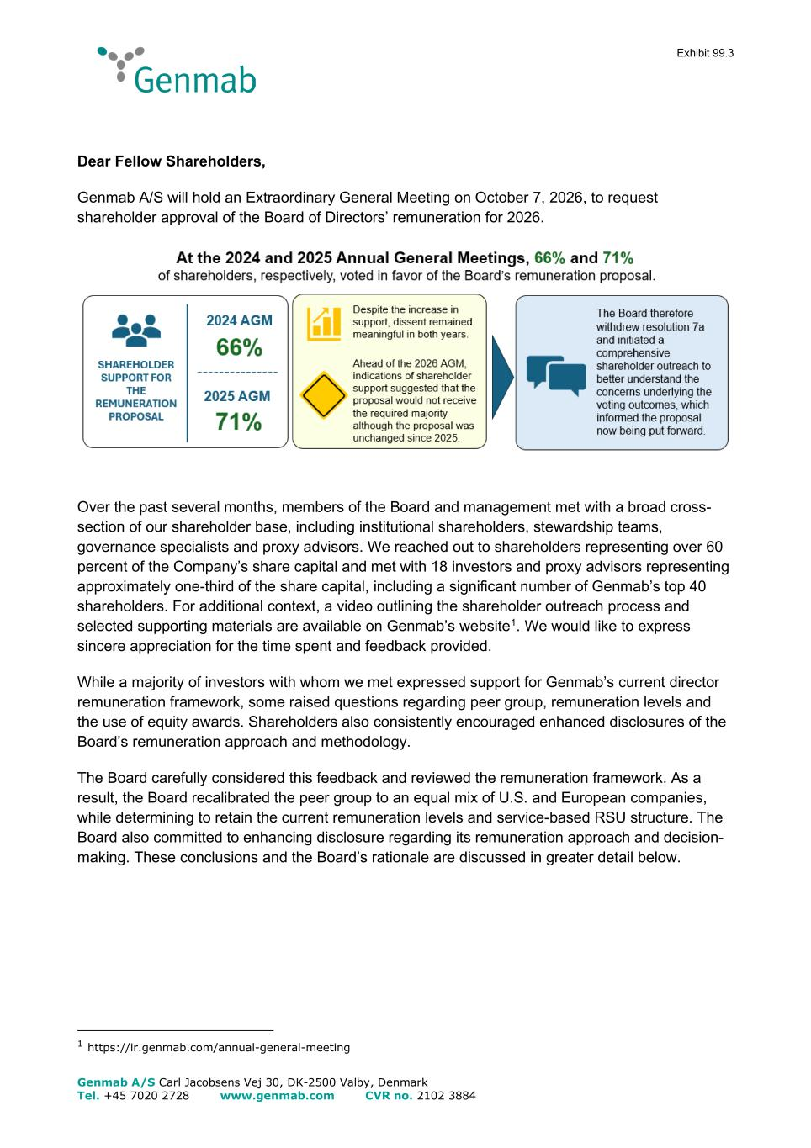

Exhibit 99.3 Genmab A/S Carl Jacobsens Vej 30, DK-2500 Valby, Denmark Tel. +45 7020 2728 www.genmab.com CVR no. 2102 3884 Dear Fellow Shareholders, Genmab A/S will hold an Extraordinary General Meeting on October 7, 2026, to request shareholder approval of the Board of Directors’ remuneration for 2026. Over the past several months, members of the Board and management met with a broad cross- section of our shareholder base, including institutional shareholders, stewardship teams, governance specialists and proxy advisors. We reached out to shareholders representing over 60 percent of the Company’s share capital and met with 18 investors and proxy advisors representing approximately one-third of the share capital, including a significant number of Genmab’s top 40 shareholders. For additional context, a video outlining the shareholder outreach process and selected supporting materials are available on Genmab’s website1. We would like to express sincere appreciation for the time spent and feedback provided. While a majority of investors with whom we met expressed support for Genmab’s current director remuneration framework, some raised questions regarding peer group, remuneration levels and the use of equity awards. Shareholders also consistently encouraged enhanced disclosures of the Board’s remuneration approach and methodology. The Board carefully considered this feedback and reviewed the remuneration framework. As a result, the Board recalibrated the peer group to an equal mix of U.S. and European companies, while determining to retain the current remuneration levels and service-based RSU structure. The Board also committed to enhancing disclosure regarding its remuneration approach and decision- making. These conclusions and the Board’s rationale are discussed in greater detail below. 1 https://ir.genmab.com/annual-general-meeting

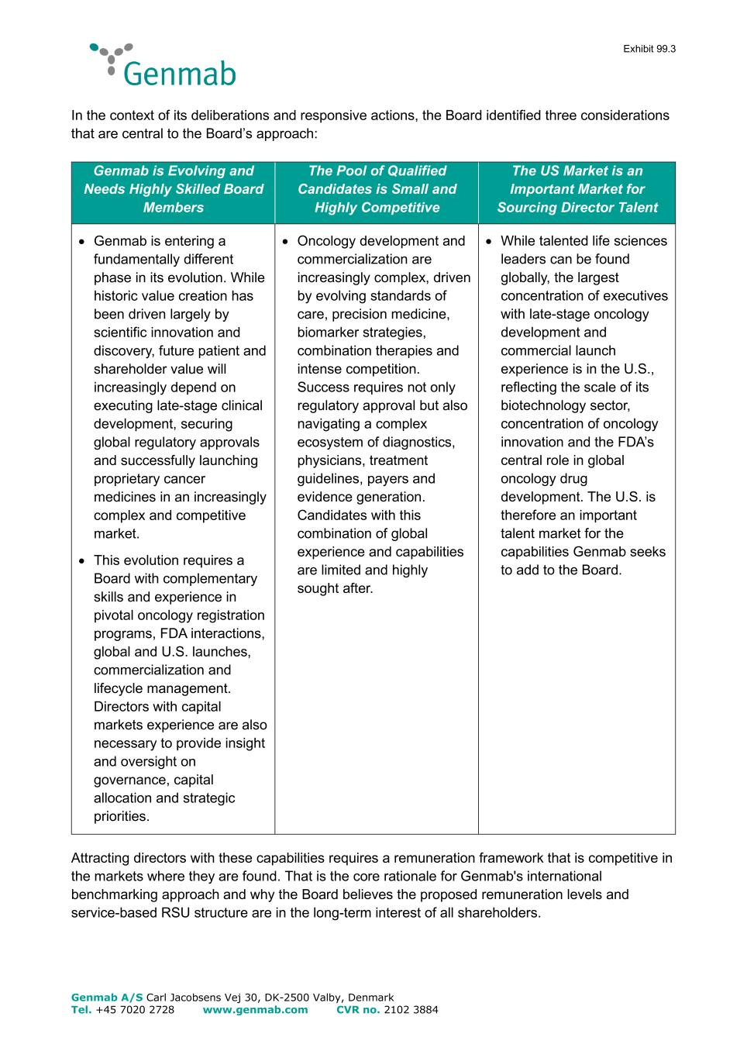
Exhibit 99.3 Genmab A/S Carl Jacobsens Vej 30, DK-2500 Valby, Denmark Tel. +45 7020 2728 www.genmab.com CVR no. 2102 3884 In the context of its deliberations and responsive actions, the Board identified three considerations that are central to the Board’s approach: Genmab is Evolving and Needs Highly Skilled Board Members The Pool of Qualified Candidates is Small and Highly Competitive The US Market is an Important Market for Sourcing Director Talent • Genmab is entering a fundamentally different phase in its evolution. While historic value creation has been driven largely by scientific innovation and discovery, future patient and shareholder value will increasingly depend on executing late-stage clinical development, securing global regulatory approvals and successfully launching proprietary cancer medicines in an increasingly complex and competitive market. • This evolution requires a Board with complementary skills and experience in pivotal oncology registration programs, FDA interactions, global and U.S. launches, commercialization and lifecycle management. Directors with capital markets experience are also necessary to provide insight and oversight on governance, capital allocation and strategic priorities. • Oncology development and commercialization are increasingly complex, driven by evolving standards of care, precision medicine, biomarker strategies, combination therapies and intense competition. Success requires not only regulatory approval but also navigating a complex ecosystem of diagnostics, physicians, treatment guidelines, payers and evidence generation. Candidates with this combination of global experience and capabilities are limited and highly sought after. • While talented life sciences leaders can be found globally, the largest concentration of executives with late-stage oncology development and commercial launch experience is in the U.S., reflecting the scale of its biotechnology sector, concentration of oncology innovation and the FDA’s central role in global oncology drug development. The U.S. is therefore an important talent market for the capabilities Genmab seeks to add to the Board. Attracting directors with these capabilities requires a remuneration framework that is competitive in the markets where they are found. That is the core rationale for Genmab's international benchmarking approach and why the Board believes the proposed remuneration levels and service-based RSU structure are in the long-term interest of all shareholders.

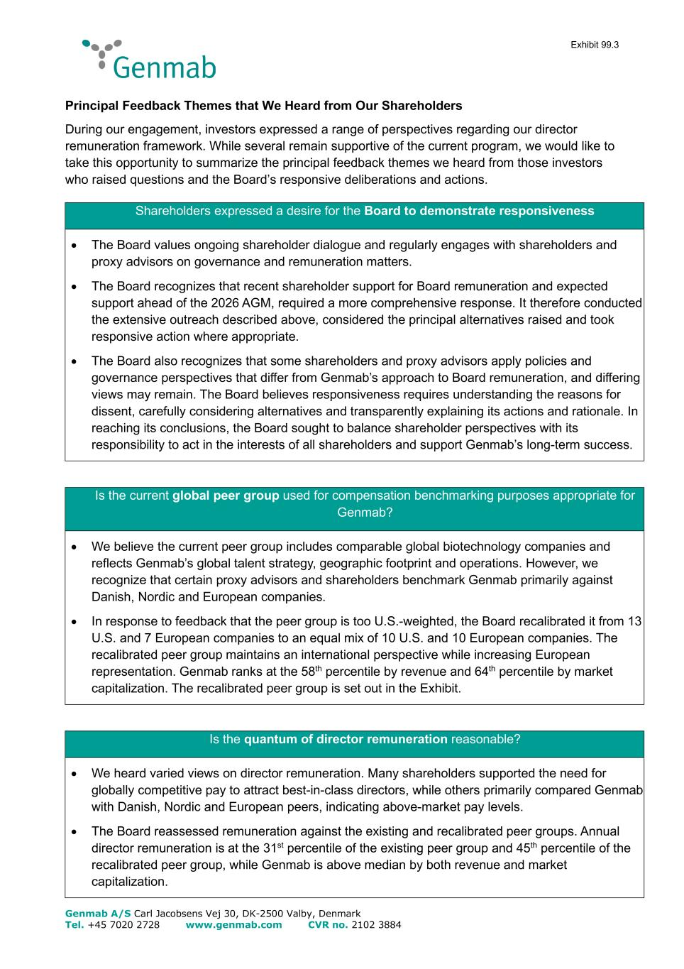
Exhibit 99.3 Genmab A/S Carl Jacobsens Vej 30, DK-2500 Valby, Denmark Tel. +45 7020 2728 www.genmab.com CVR no. 2102 3884 Principal Feedback Themes that We Heard from Our Shareholders During our engagement, investors expressed a range of perspectives regarding our director remuneration framework. While several remain supportive of the current program, we would like to take this opportunity to summarize the principal feedback themes we heard from those investors who raised questions and the Board’s responsive deliberations and actions. Shareholders expressed a desire for the Board to demonstrate responsiveness • The Board values ongoing shareholder dialogue and regularly engages with shareholders and proxy advisors on governance and remuneration matters. • The Board recognizes that recent shareholder support for Board remuneration and expected support ahead of the 2026 AGM, required a more comprehensive response. It therefore conducted the extensive outreach described above, considered the principal alternatives raised and took responsive action where appropriate. • The Board also recognizes that some shareholders and proxy advisors apply policies and governance perspectives that differ from Genmab’s approach to Board remuneration, and differing views may remain. The Board believes responsiveness requires understanding the reasons for dissent, carefully considering alternatives and transparently explaining its actions and rationale. In reaching its conclusions, the Board sought to balance shareholder perspectives with its responsibility to act in the interests of all shareholders and support Genmab’s long-term success. Is the current global peer group used for compensation benchmarking purposes appropriate for Genmab? • We believe the current peer group includes comparable global biotechnology companies and reflects Genmab’s global talent strategy, geographic footprint and operations. However, we recognize that certain proxy advisors and shareholders benchmark Genmab primarily against Danish, Nordic and European companies. • In response to feedback that the peer group is too U.S.-weighted, the Board recalibrated it from 13 U.S. and 7 European companies to an equal mix of 10 U.S. and 10 European companies. The recalibrated peer group maintains an international perspective while increasing European representation. Genmab ranks at the 58th percentile by revenue and 64th percentile by market capitalization. The recalibrated peer group is set out in the Exhibit. Is the quantum of director remuneration reasonable? • We heard varied views on director remuneration. Many shareholders supported the need for globally competitive pay to attract best-in-class directors, while others primarily compared Genmab with Danish, Nordic and European peers, indicating above-market pay levels. • The Board reassessed remuneration against the existing and recalibrated peer groups. Annual director remuneration is at the 31st percentile of the existing peer group and 45th percentile of the recalibrated peer group, while Genmab is above median by both revenue and market capitalization.

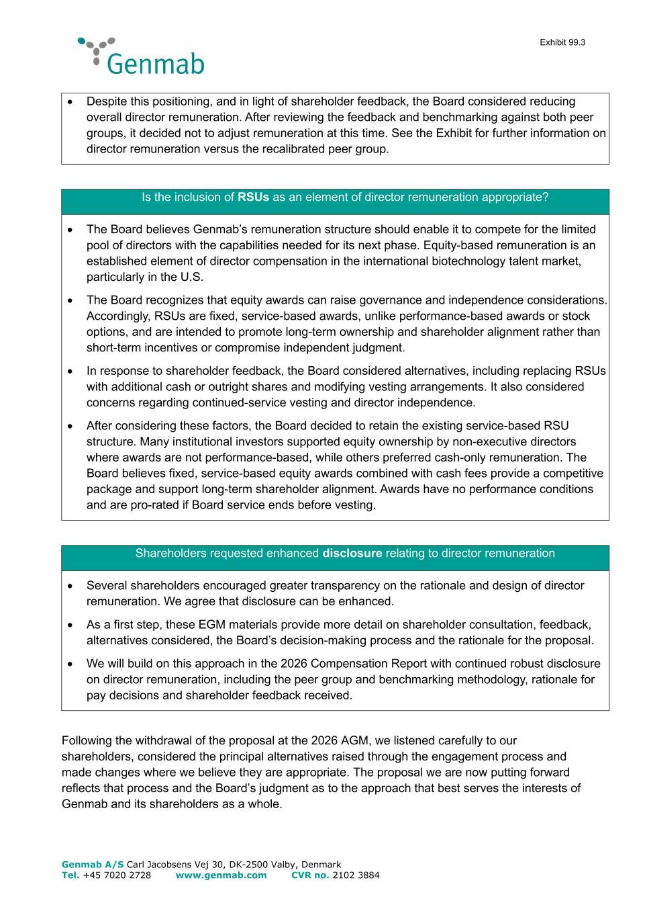
Exhibit 99.3 Genmab A/S Carl Jacobsens Vej 30, DK-2500 Valby, Denmark Tel. +45 7020 2728 www.genmab.com CVR no. 2102 3884 • Despite this positioning, and in light of shareholder feedback, the Board considered reducing overall director remuneration. After reviewing the feedback and benchmarking against both peer groups, it decided not to adjust remuneration at this time. See the Exhibit for further information on director remuneration versus the recalibrated peer group. Is the inclusion of RSUs as an element of director remuneration appropriate? • The Board believes Genmab’s remuneration structure should enable it to compete for the limited pool of directors with the capabilities needed for its next phase. Equity-based remuneration is an established element of director compensation in the international biotechnology talent market, particularly in the U.S. • The Board recognizes that equity awards can raise governance and independence considerations. Accordingly, RSUs are fixed, service-based awards, unlike performance-based awards or stock options, and are intended to promote long-term ownership and shareholder alignment rather than short-term incentives or compromise independent judgment. • In response to shareholder feedback, the Board considered alternatives, including replacing RSUs with additional cash or outright shares and modifying vesting arrangements. It also considered concerns regarding continued-service vesting and director independence. • After considering these factors, the Board decided to retain the existing service-based RSU structure. Many institutional investors supported equity ownership by non-executive directors where awards are not performance-based, while others preferred cash-only remuneration. The Board believes fixed, service-based equity awards combined with cash fees provide a competitive package and support long-term shareholder alignment. Awards have no performance conditions and are pro-rated if Board service ends before vesting. Shareholders requested enhanced disclosure relating to director remuneration • Several shareholders encouraged greater transparency on the rationale and design of director remuneration. We agree that disclosure can be enhanced. • As a first step, these EGM materials provide more detail on shareholder consultation, feedback, alternatives considered, the Board’s decision-making process and the rationale for the proposal. • We will build on this approach in the 2026 Compensation Report with continued robust disclosure on director remuneration, including the peer group and benchmarking methodology, rationale for pay decisions and shareholder feedback received. Following the withdrawal of the proposal at the 2026 AGM, we listened carefully to our shareholders, considered the principal alternatives raised through the engagement process and made changes where we believe they are appropriate. The proposal we are now putting forward reflects that process and the Board’s judgment as to the approach that best serves the interests of Genmab and its shareholders as a whole.

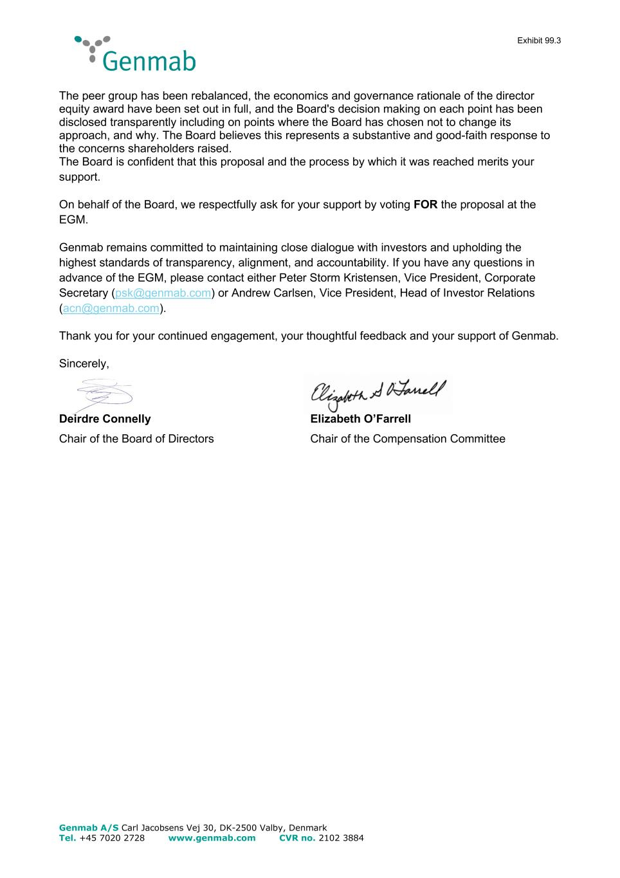
Exhibit 99.3 Genmab A/S Carl Jacobsens Vej 30, DK-2500 Valby, Denmark Tel. +45 7020 2728 www.genmab.com CVR no. 2102 3884 The peer group has been rebalanced, the economics and governance rationale of the director equity award have been set out in full, and the Board's decision making on each point has been disclosed transparently including on points where the Board has chosen not to change its approach, and why. The Board believes this represents a substantive and good-faith response to the concerns shareholders raised. The Board is confident that this proposal and the process by which it was reached merits your support. On behalf of the Board, we respectfully ask for your support by voting FOR the proposal at the EGM. Genmab remains committed to maintaining close dialogue with investors and upholding the highest standards of transparency, alignment, and accountability. If you have any questions in advance of the EGM, please contact either Peter Storm Kristensen, Vice President, Corporate Secretary (psk@genmab.com) or Andrew Carlsen, Vice President, Head of Investor Relations (acn@genmab.com). Thank you for your continued engagement, your thoughtful feedback and your support of Genmab. Sincerely, Deirdre Connelly Elizabeth O’Farrell Chair of the Board of Directors Chair of the Compensation Committee

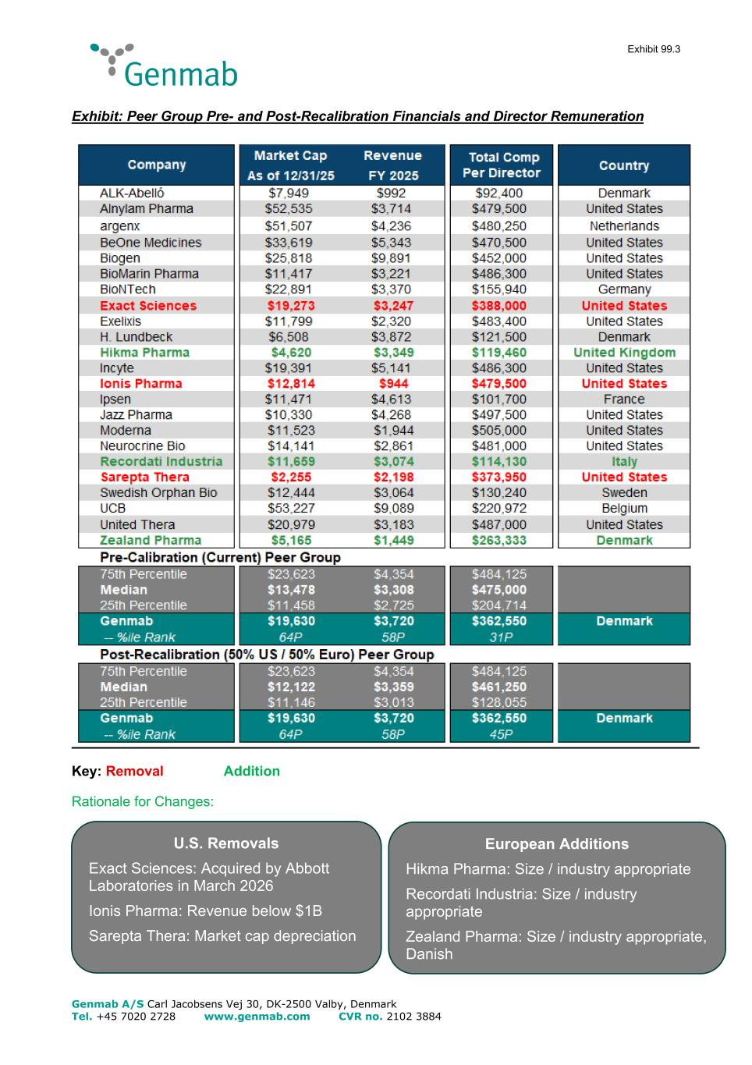
Exhibit 99.3 Genmab A/S Carl Jacobsens Vej 30, DK-2500 Valby, Denmark Tel. +45 7020 2728 www.genmab.com CVR no. 2102 3884 Exhibit: Peer Group Pre- and Post-Recalibration Financials and Director Remuneration Key: Removal Addition Rationale for Changes: U.S. Removals Exact Sciences: Acquired by Abbott Laboratories in March 2026 Ionis Pharma: Revenue below $1B Sarepta Thera: Market cap depreciation European Additions Hikma Pharma: Size / industry appropriate Recordati Industria: Size / industry appropriate Zealand Pharma: Size / industry appropriate, Danish

